## 4.4.2. User Account

**4.4.2.1. User Account – User Interface**

**4.4.2.1.1. Register**

4.4.2.1.1.1. Register - Screen Images

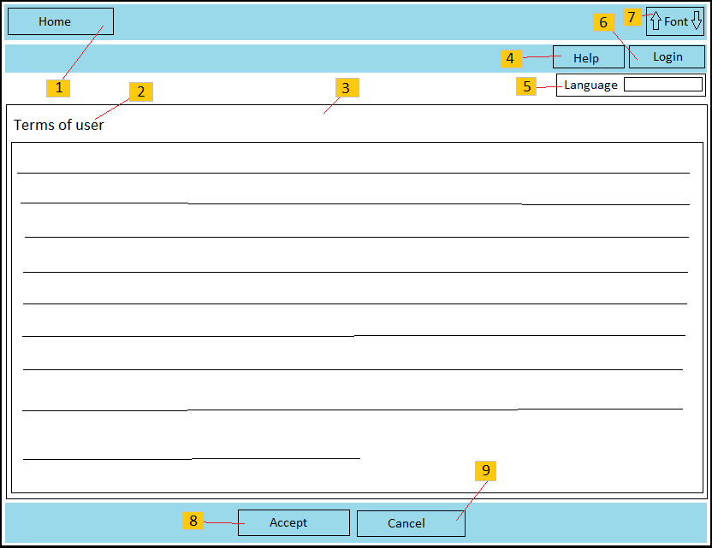

**Figure 4.12:** “E-Learning” register page

4.4.2.1.1.2. Register - Description of the User Interface

|  |  |  |
| --- | --- | --- |
| No | Name | Description |
| 1 | “Home page” link | Click on the link to access “Home page” site. |
| 2 | Register label | Show page where user is in. |
| 3 | “Term of users” content area | Display the content for “term of users” between user and “E-Learning” owners. |
| 4 | FAQ link | Show frequently asked questions can meet. |
| 5 | “Language” list box | Allow user to choose language to display the website. |
| 6 | Login link | Click on the link to access login site. |
| 7 | “Font size” button | Allow user to change font size of the website. Click on down arrow which is left to decrease font size and click on up arrow which is right to increase font size. |
| 8 | Agree button | Click on the button will allow user send the registration request to “E-Learning” system. |
| 9 | Disagree button | Click on the button to refuse to register. |

**4.4.2.1.2. User Setting**

4.4.2.1.2.1. User Setting - Screen images

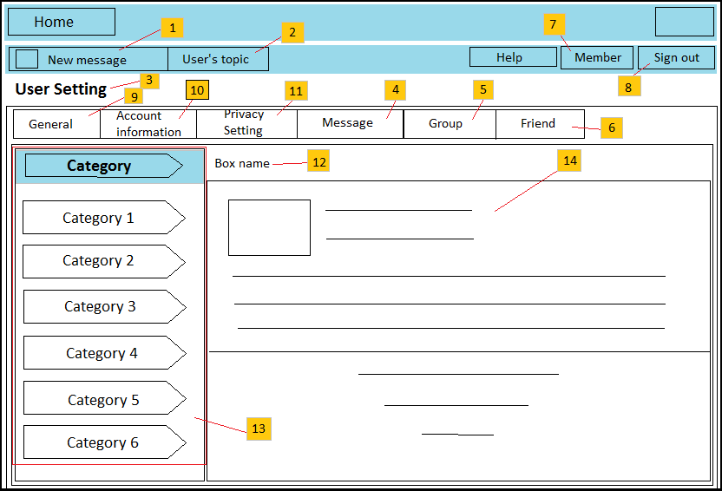

**Figure 4.13:** “E-Learning” user setting page

4.4.2.1.2.2. User Setting - Description of the User Interface

|  |  |  |
| --- | --- | --- |
| No | Name | Description |
| 1 | Message label | Show numbers of messages of user are read yet. |
| 2 | “Article of user” link | Click on the link to show articles of user. |
| 3 | User Setting label | Show the place where user is in. |
| 4 | Message box | Display messages of user and allow user to write message for another user. |
| 5 | Group box | Display group which user is joined. |
| 6 | Friend box | Display close friends and enemies of user. |
| 7 | Member link | Show all of members joined to the website. |
| 8 | Sign out button | User can sign out of the system when click on the button. |
| 9 | General box | Allow user to manage favorite page, draft article, attach file…. |
| 10 | Account Information box | Allow user to see and change privacy information. |
| 11 | Privacy setting box | Allow users to manage privacy system setting of them. |
| 12 | Box label | Display name of box where user is in. |
| 13 | Categories of box | Display categories of box where user is in. |
| 14 | Content of category | Display content of each of category. |

## 4.4.3. Report

**4.4.3.1. Report – User Interface**

**4.4.3.1.1. Default report**

4.4.3.1.1.1. Default report – Screen Images

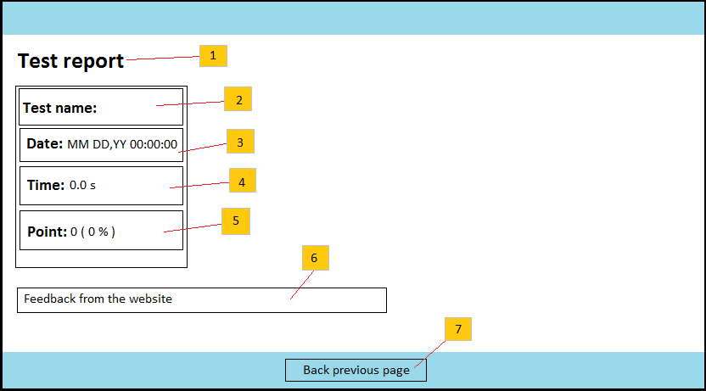

**Figure 4.14:** Test result page

4.4.3.1.1.1. Default report – Description of the User Interface

|  |  |  |
| --- | --- | --- |
| No | Name | Description |
| 1 | Report label | Display the page where user is in. |
| 2 | Test name | Display name of test which user did recently. |
| 3 | Test date | Display date and time of report is published. |
| 4 | Test time | Display time which user use to do the test. |
| 5 | Test mark | Display mark of test which user achieved. |
| 6 | Test feedback | Show feedback of the system about process which user did the test. |
| 7 | Previous page button | Click on the button to go back preparing test page. |

**4.4.3.1.2. Detail report**

4.4.3.1.2.1. Detail report – Screen Images

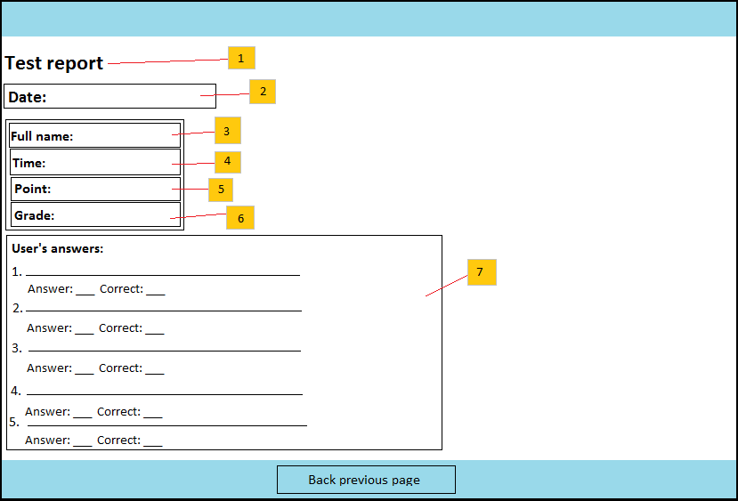

**Figure 4.15:** Detail result page

4.4.3.1.2.2. Detail report – Description of the User Interface

|  |  |  |
| --- | --- | --- |
| No | Name | Description |
| 1 | Report label | Display the page where user is in. |
| 2 | Test date | Display date and time of report is published. |
| 3 | Name of user | Show last name and first name of user. |
| 4 | Test time | Display time which user use to do the test. |
| 5 | Test mark |  |
| 6 | Test grade |  |
| 7 | Answer detail | Display answer of each question of the test which user choose. |

**4.4.3.2. Report – Class Diagram**

**4.4.3.3. Report – Class Diagram Explanation**

## 4.4.4. Test

**4.4.4.1. Test – User Interface**

**4.4.4.1.1. Preparing test**

4.4.4.1.1.1. Preparing test - Screen images

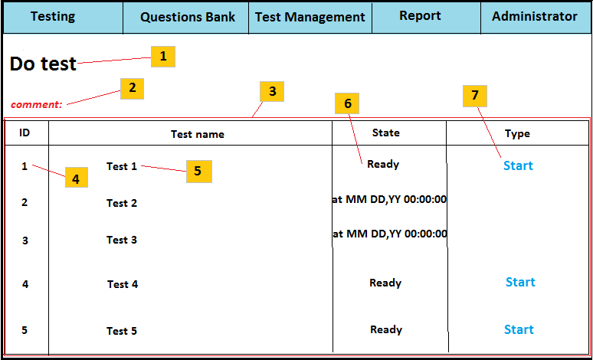

**Figure 4.16:** Test preparing page

4.4.4.1.1.2. Preparing test - Description of the User Interface

|  |  |  |
| --- | --- | --- |
| No | Name | Description |
| 1 | Test label | Show the place where user is in. |
| 2 | Test feedback | Show feedback if a test doesn’t have any question. |
| 3 | Test panel | The panel contains information of test |
| 4 | Test ID | Show ID of test |
| 5 | Test name | Show name of test |
| 6 | Test status | Show status of test. |
| 7 | Start button | Click on the button to start doing a test |

**4.4.4.1.2. Test process:**

4.4.4.1.2.1. Test process – Screen Images:

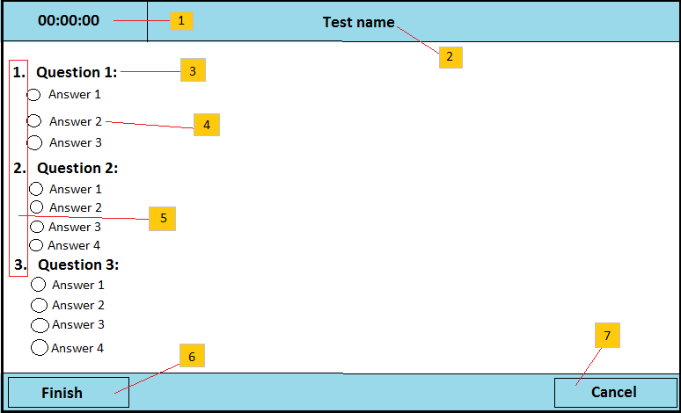

**Figure 4.17:** Test page

4.4.4.1.2.2. Test process - Description of the User Interface

|  |  |  |
| --- | --- | --- |
| No | Name | Description |
| 1 | Test time | Time to do the test; time will count down to 0. |
| 2 | Test name | Name of test |
| 3 | Name of question | Show name of question |
| 4 | Answers of question | Show answers of question |
| 5 | Order of questions | Display order of questions |
| 6 | Finish button | Click on button to finish the test. |
| 7 | Cancel button | Click on button to cancel the test. |

**4.4.4.2. Test – Class Diagram**

**4.4.4.3. Test – Class Diagram Explanation**